CUSTOMER SCREEN
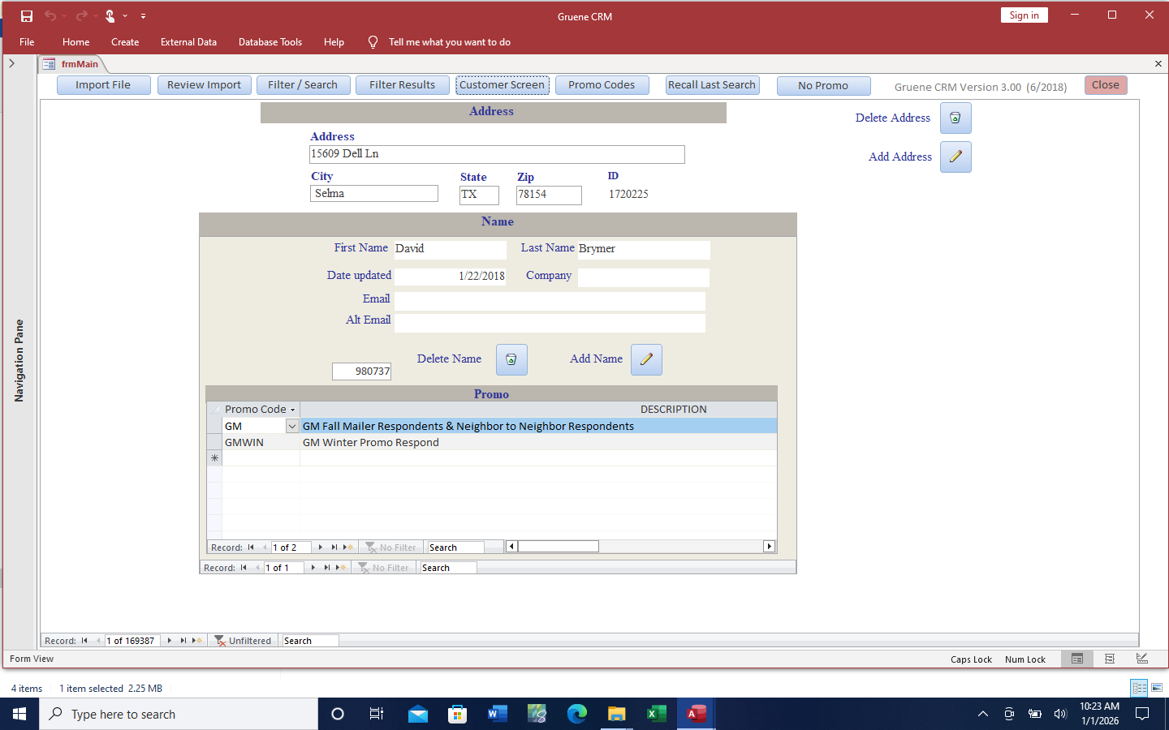

Import Screen
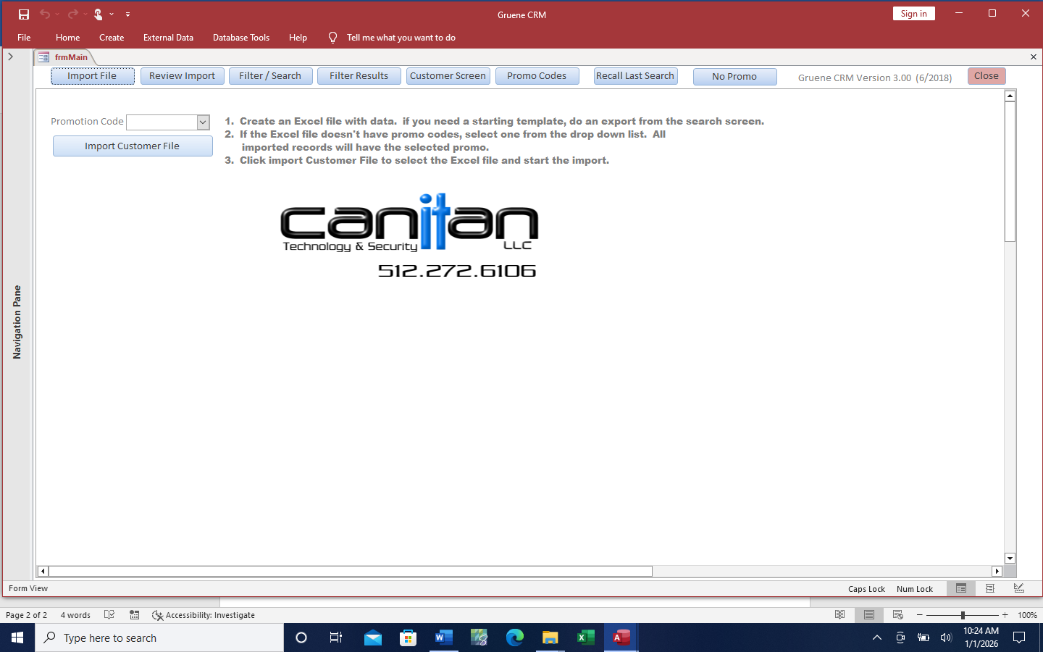

Filter Screen
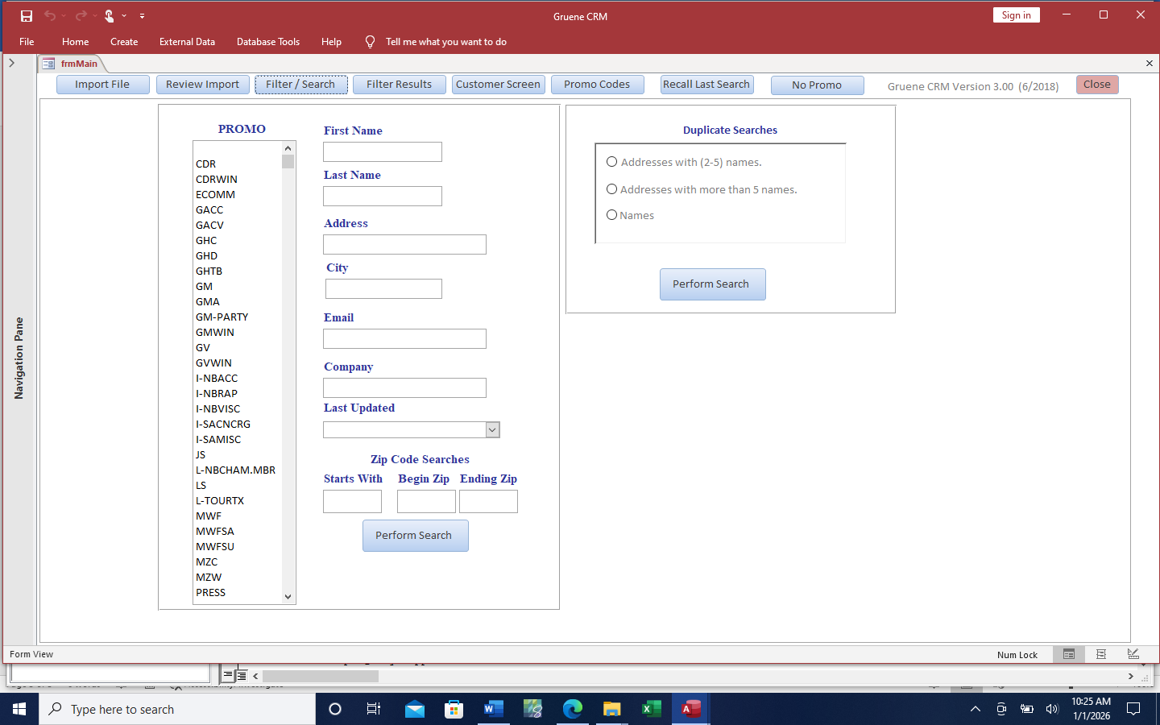

FILTER RESULTS SCREEN ALLOWS EDITING, HYPER LINK TO CUSTOMER SCREEN, EXPORT TO EXCEL AND DELETE
